`python3 hex_grader.py` to run games. It will read the three bot files in the bot folder and play them against each other, then store the resulting game as a json in the ./games directory.

`python3 hex_visualizer` to visualize the json game files.

* Press <- -> to go forward/back, hold for fast
* Press C to toggle coordinate
* Press Space to load another save

# For MacOS users

pygame may be broken on MacOS, in which case you will run into an error when running hex_visualizer. In this case, we recommend instead running the visualizer online, particularly on <https://replit.com/>. Steps for doing so:

1. Navigate to replit.

2. Create an account or sign in if you have one.

3. On the home page, press “Create Repl.”

4. In the top right, press “Import from GitHub”

5. Press “From URL.” For the GitHub Repository URL, paste in <https://github.com/topazand/CMIMC2024-DCON5-Visualizer>

6. Press “Import from GitHub.”

7. In the “Configure the Run Command” section, type in python3 main.py then press Done: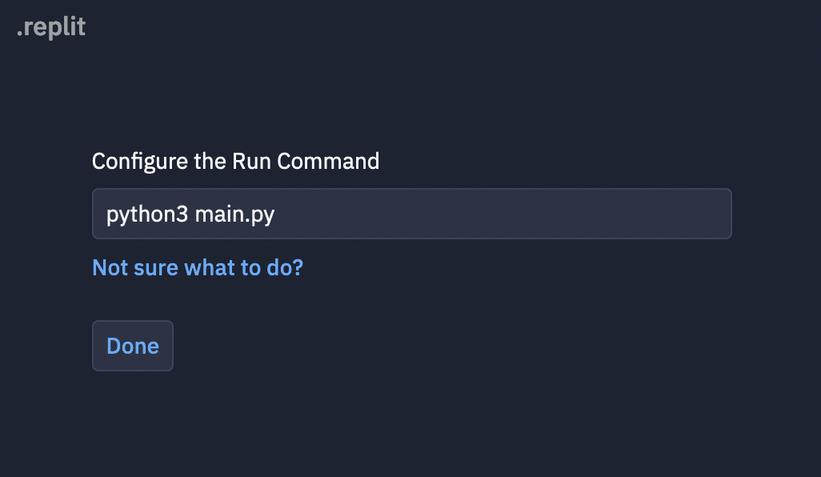

After following the above instructions, you can now visualize matches. To visualize a match, upload the match JSON file to the replit under the games directory. Then, you can press “Run” in the replit. The console will ask you which file to visualize: simply put the title of the file you uploaded, and the visualization will appear. You can press the PyGame screen in replit and the left and right arrow keys to step through the visualization.

If you are having any issues with the above instructions, feel free to reach out on the Discord server.

**Warning: Your replit project is public. Other contestants will be able to see its contents. Do not upload your bot code to the project!**